For Windows users, there are some slight instruction variations:

1. Download and install Atom from <https://atom.io/> (<http://flight-manual.atom.io/getting-started/sections/installing-atom/>)
2. For Windows, Atom Shell Commands are automatically installed upon launching Atom for the first time
3. Install two Atom packages: Emmet (<https://atom.io/packages/emmet>) and MarkDown Preview (<https://atom.io/packages/markdown-preview>)
   * + Open Atom
     + Click File…Settings
     + Click the Install tab
     + Search for Emmet and install, and search for MarkDown Preview and install

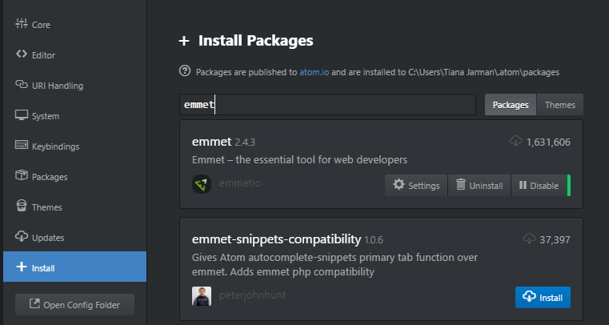

**NOTE**: When following the instructions to submit the assignment, ensure that you are using **PowerShell** and not the standard Command Prompt   
 